Operational modal analysis

Performed experimental and simulation analysis by performing modal analysis of a bike chassis to find the mode shapes and natural frequencies of a bike chassis. A running engine was simulated on the chassis to see how it alters the natural frequencies of a chassis.









CATIA V5 R20 , HyperMesh , ANSYS , MeScope

Effect of Toe Camber and Caster

Studied the effects of Toe, Camber and Caster angles on the vehicle performance for different classes of vehicles ranging from Sedans to SUV’s





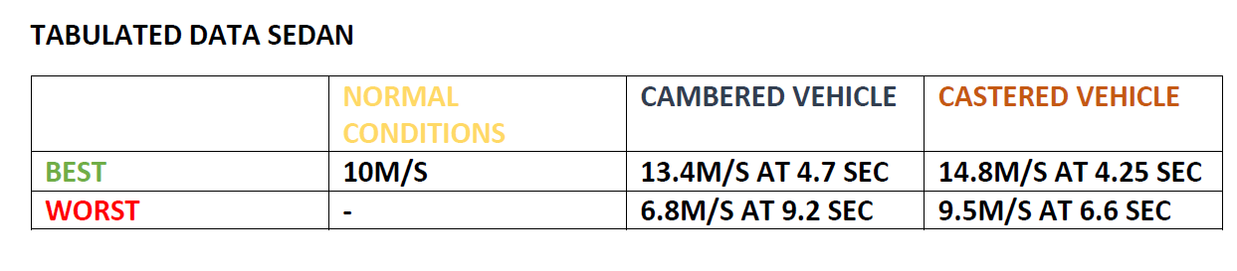

MATLAB , Tire Dynamics , Automotive design

Vibration pattern of a membrane

Analyzed mode shapes of a circular membrane by impinging sound generated waves on the surface with the help of a speaker within a circular tube







MATLAB , Modal Analysis

Prosthetic design

Set up the design for a prosthetic which can be used for fixing Foot drop gait.







Prosthetic design , Data Analysis , Neurology

Satellite dynamics

Analyzed the path and maneuvering required for the orbital path of a service satellite to refuel an existing satellite.

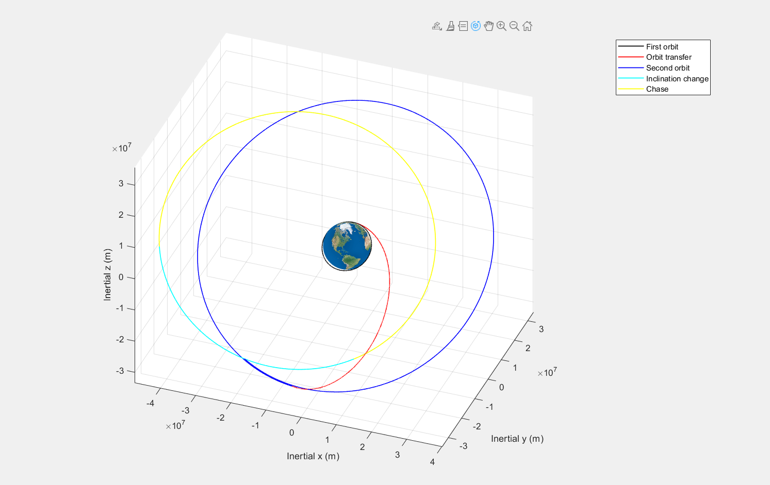

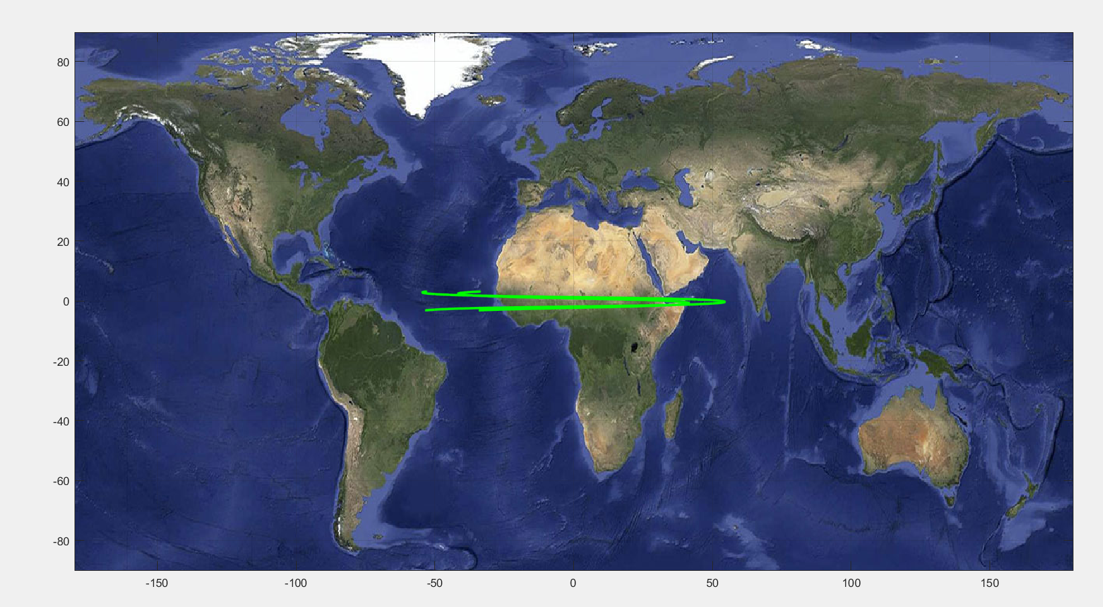

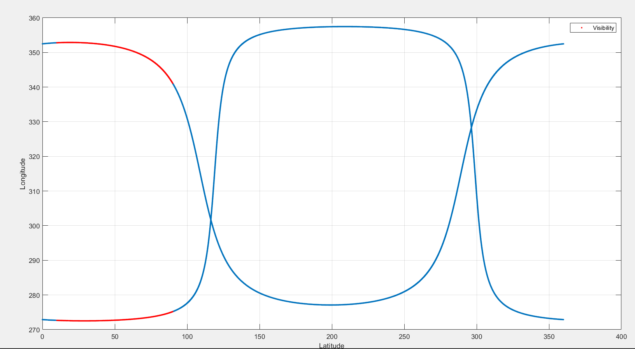

MATLAB , Space Dynamics , Orbital Maneuvers

Exoplanet detection and Orbital analysis

Determined which planets are habitable by classifying them as planets or exo space objects and comparing them to the dynamics of the Earth as a reference.









MATLAB , Data Analysis , Earth Dynamics , Orbital planning

Travelling wave generation

Simulated a travelling wave on the surface of a plate which is to be replicated on the surface of an aircraft wing to promote better boundary layer control. This is used to improve flight performance for high speed travel.















CATIA V5 R21 , ANSYS , MATLAB , COMSOL

PCB Board design

Calculated the thermal dissipative properties of PCB boards to prevent overheating during usage in Telecom towers.

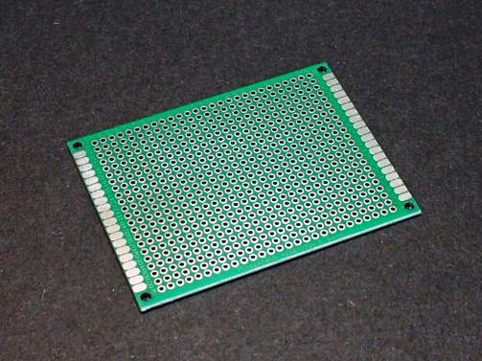

Thermodynamics

Physics of Robots

Designed a compliant robot to analyze the working and stress limits of the mechanism. Further researched dynamical properties of jumping robots







CATIA V5 R20 , MATLAB , 3D Printing